18.42: a) 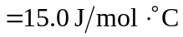
b) Vibrational degrees of freedom become more important. c) 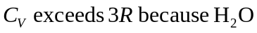 also has rotational degrees of freedom.

